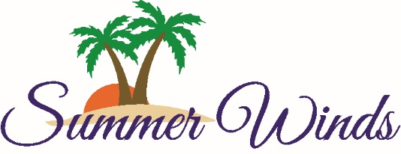
Homeowner’s Association
1505 Salter Path Road
Atlantic Beach, NC 28512
252-247-2080 / summerwindscondos.com

Summer Winds Condominiums, Inc.
Annual Membership Meeting
October 26, 2019, 10:00 a.m.
Ginger’s Café

Agenda

- Call to Order; Luther Griffin, President
- Roll call and certification of proxies; Sharon Scott, Secretary
- Proof of Notice of Meeting; Sandy Plisko, Executive Director
- Approval of 2018 Annual Meeting Minutes; Sharon Scott, Secretary
- Officer’s Reports:
  - President’s Report, presented by President Luther Griffin
  - Treasurer’s Report, presented by President Luther Griffin
- Old Business
- New Business
- Election of board members
- Special Recognitions
- Adjournment

